**GPS Tracking and Fleet Management:**

* Equip public transport vehicles (buses, trams, etc.) with GPS tracking devices.
* Collect real-time location data to monitor the entire fleet.
* Implement a dashboard for route optimization, driver monitoring, and maintenance scheduling.

**Introduction:**

* By combining GPS fleet tracking and telematics technologies, GPS fleet management can unlock valuable information about fleets and help them to improve their operations.
* **With GPS fleet management, fleet managers are able to do things like track their vehicles’ speed and location with GPS technologies, while also receiving information on engine status and safety measures via telematics devices.**This is just a small sample of the wide array of data that GPS fleet management software collects.
* GPS fleet management software has many benefits. It can help fleets to improve their maintenance operations, boost their safety record, and lower their fuel consumption.

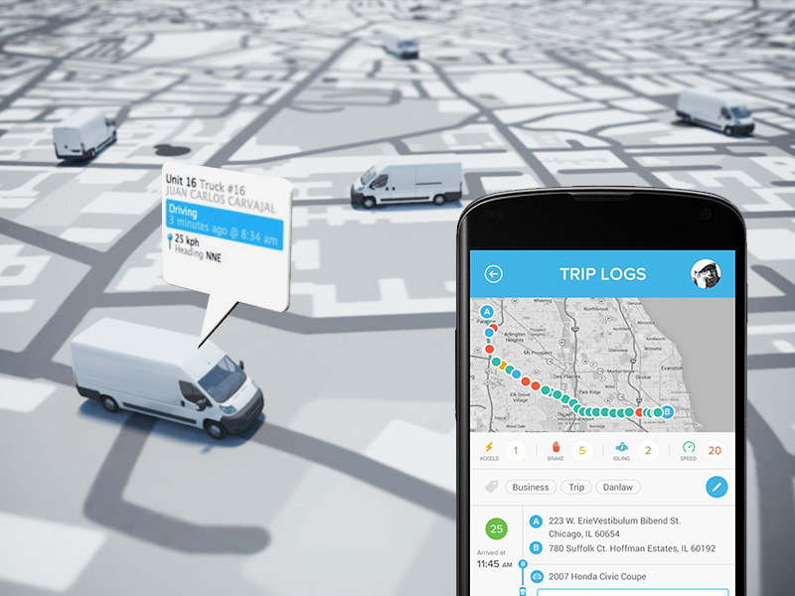

## What Is GPS Fleet Management?

## The term “GPS fleet management” refers to fleet management software that uses telematics and GPS fleet tracking technologies. In order to understand what GPS fleet management is, it’s important to be familiar with its components—GPS, telematics, GPS fleet tracking, and fleet management software.

### **What Is GPS?**

### GPS is a navigation system that can provide data such as location, time synchronization, and velocity. It works on land, in the air, and even at sea – anywhere a satellite signal is available.

### GPS stands for Global Positioning System. GPS was originally created by and for the United States military. The system has been around since the first GPS satellite was launched in February of 1978.

### **In March of 1996, US president Bill Clinton recognized the importance of GPS for civilian use and declared GPS a dual-use system. This allowed it to be used by both the military and civilians.** He also created an executive board to manage GPS.

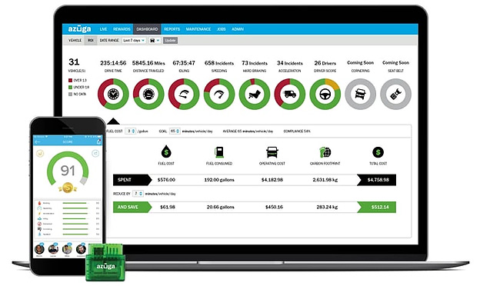

The United States federal government provides GPS technology—for peaceful uses—globally and free of charge.

#### **The Three GPS Segments**:

GPS is made up of three components known as “segments”. These segments work together to provide GPS functionality. The segments are space, control, and user.

* **Space – The space segment is comprised of 28 satellites. Each satellite has its own orbit, approximately 11,000 nautical miles above the surface of Earth.**
* **Control – The control segment consists of five ground stations, spaced all over the world. They interact with the space segment to make sure the satellites are in working order.**
* **User – The user segment is composed of receivers. Receivers interact with satellites to pinpoint their exact locations**

**What Is GPS Fleet Tracking?**

GPS fleet tracking involves using GPS receivers inside of fleet vehicles to track their location, speed, route, and more. This information is sent to the fleet manager who can use it to understand driver behavior, reduce dangerous driving habits, and improve vehicle efficiencies.

**What Is Telematics?**

Telematics combines GPS tracking with on-board diagnostics. A large amount of data can be collected with telematics devices and other sensors. This includes information such as vehicle speed, vehicle location, idling time, fuel consumption, and seat belt use. Telematics devices often plug into a vehicle’s OBD-II port to record engine data as well.

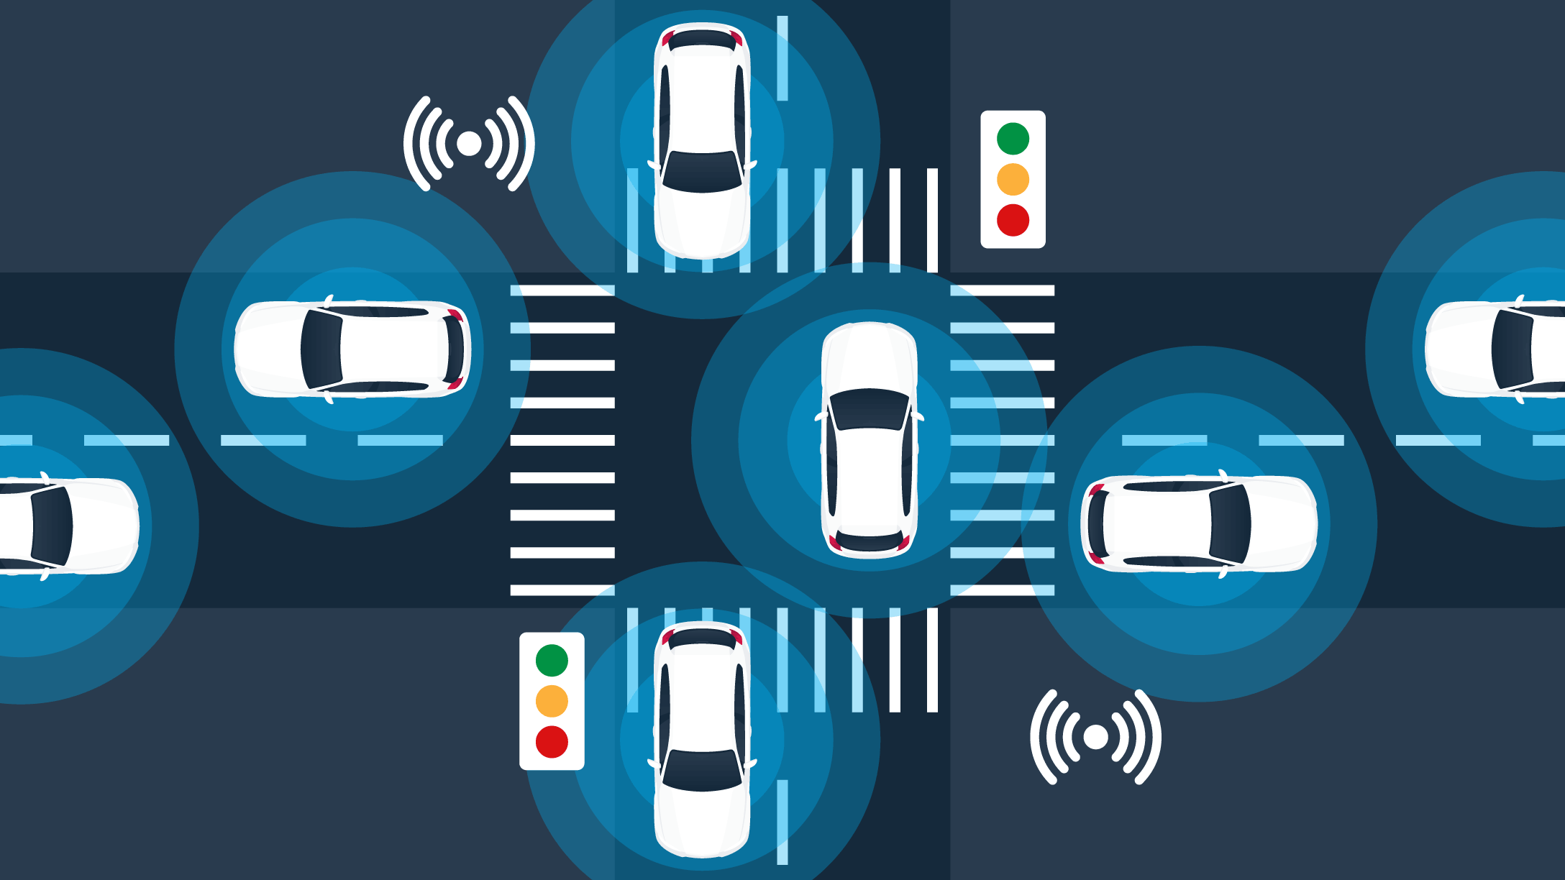

**What Is Fleet Management Software?**

Fleet management software is a centralized information system used by companies to help them better manage, synchronize, and organize their fleets. Fleet management software helps ensure fleets run efficiently.

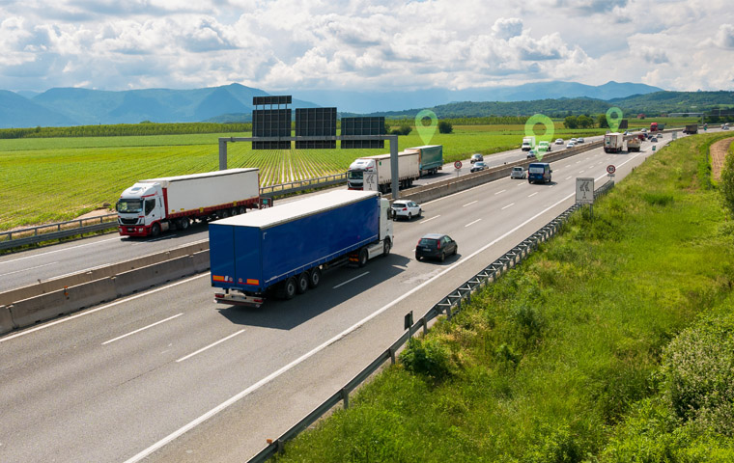

* The goal of fleet management software is to reduce operating costs and boost the fleet’s performance. In addition, the software helps fleets keep on top of government regulations.
* Fleet management software has a number of useful functionalities, like route optimization and planning, maintenance scheduling, and safety monitoring.
* When you combine fleet management software with GPS fleet tracking and telematics technologies, you get GPS fleet management

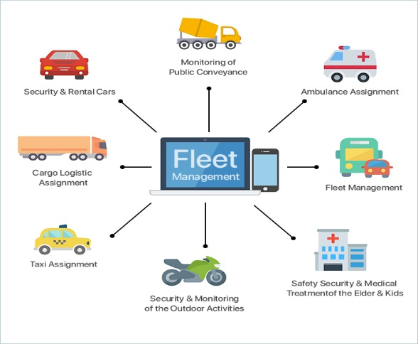

Benefits of GPS Fleet Management:

### **1. Maximize Vehicle Utilization**

### **2. Reduce Insurance Costs**

### **3. Reduce Fuel Costs**

### **4. Reduce Fleet Maintenance Costs**

### **5. Improve Route Planning**

### **6. Improve Fleet Security**

### **7. Get Real-time Information**

### **8. Improve Time Management**

### **9. Improve Customer Satisfaction**

### **10. Integrate with Enterprise Applications**

## Conclusion

The complementary combination of telematics and GPS fleet tracking technologies makes GPS fleet management software a powerhouse of information. This information can be used by fleet managers in a number of ways to improve their fleet’s efficiency and optimize its performance. Three important ways that fleets benefit from GPS fleet management software are superior maintenance, safety, and fuel monitoring.

‍

## 

### 

### 